Breakout

Reshma Sherugar 14101A0020

Prachi Bhavsar 14101A0021

Nihar Bhusari 14101A0068

2016-2017

INFT-A

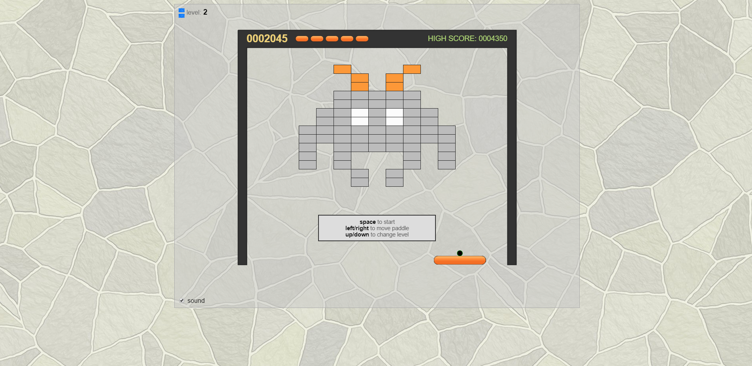

Sub: CGVR

Prof. Santosh Tamboli

Introduction:

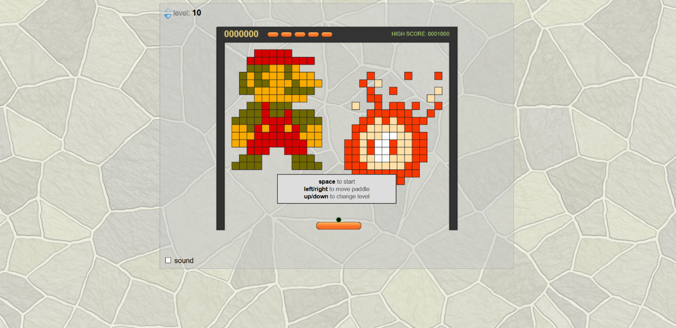*Breakout* is an arcade game developed and published by Atari, Inc.It was conceptualized by Nolan Bushnell and Steve Bristow, influenced by the 1972 Atari arcade game *Pong*, and built by Steve Wozniak aided by Steve Jobs. The game was ported to multiple platforms and upgraded to video games such as *Super Breakout*. In addition, *Breakout* was the basis and inspiration for certain aspects of the Apple II personal computer.

In the game, a layer of bricks lines the top third of the screen. A ball travels across the screen, bouncing off the top and side walls of the screen. When a brick is hit, the ball bounces away and the brick is destroyed. The player loses a turn when the ball touches the bottom of the screen. To prevent this from happening, the player has a movable paddle to bounce the ball upward, keeping it in play.

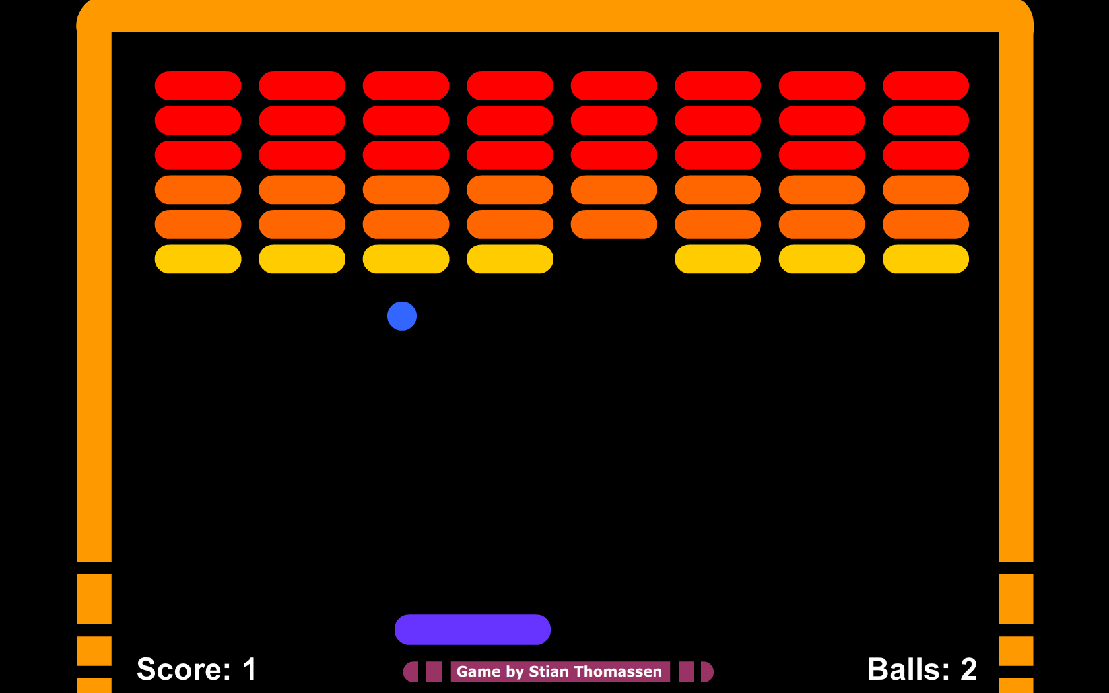

Code: